DAY 4:

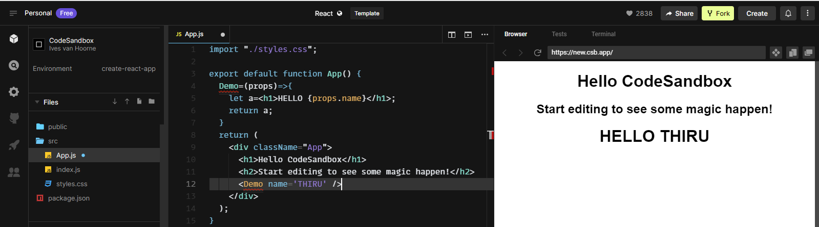

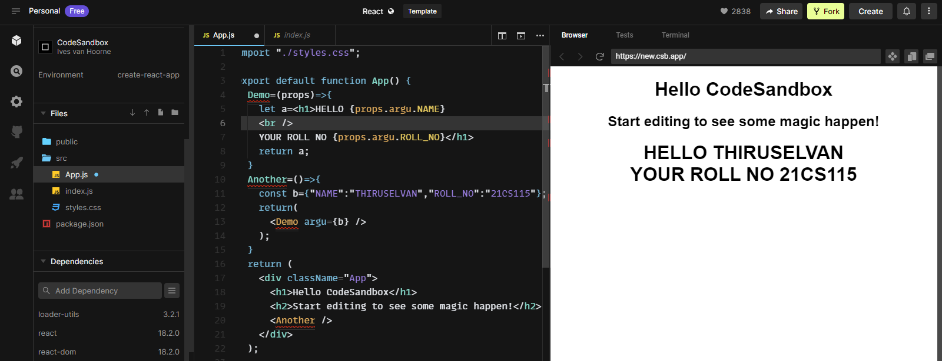

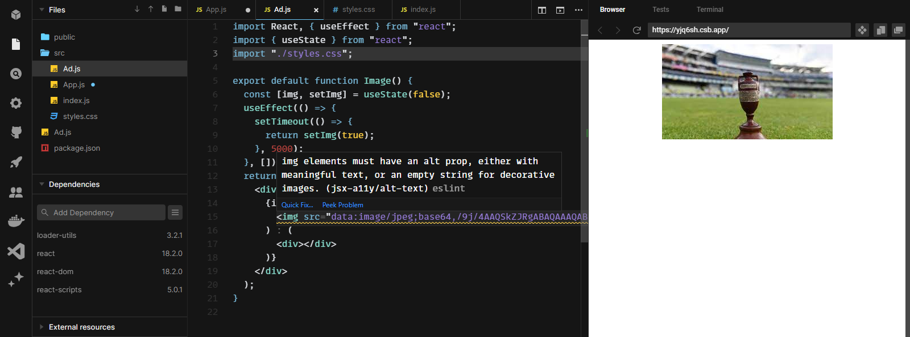

import React, { useState } from "react";

export default function Form() {

const [name, setName] = useState("");

const [number, setNumber] = useState([]);

const [dob, setDob] = useState([]);

Main = () => {

if (!name) {

alert("Please enter your name");

}

if (number.length < 10) {

alert("Please enter your mobile number");

}

if (number.length > 10) {

alert("More than 10 digits");

}

if (!dob) {

alert("Please enter your dob");

}

if (

document.getElementById("name").value === name &&

document.getElementById("number").value === number &&

document.getElementById("dob").value === dob

) {

alert("Submitted successfully");

}

};

return (

<>

<div className="form">

<h1>REGISTRATION FORM</h1>

<label>NAME</label>

<input

type="text"

id="name"

value={name}

placeholder="Enter your name"

onChange={(e) => setName(e.target.value)}

/>

<br />

<br />

<label>PHONE</label>

<input

maxLength="10"

type="number"

value={number}

id="number"

placeholder="Enter your mobile no."

onChange={(e) => setNumber(e.target.value)}

/>

<br />

<br />

<label>DOB</label>

<input

type="date"

id="dob"

value={dob}

onChange={(e) => setDob(e.target.value)}

/>

<br />

<br />

<button type="submit" onClick={Main}>

{" "}

SUBMIT{" "}

</button>

</div>

</>

);

}

